* CREATE DATABASE school_db.
* CREATE TABLE students(studentId int PRIMARY KEY AUTO_INCREMENT,student_Name varchar(20),age int ,class varchar(20) , address varchar(50));
* INSERT into students(student_Name,age,class,address)values("Vatsal","21","Python","Surat");

INSERT into students(student_Name,age,class,address)values("Harsh","21","Java","Surat");

INSERT into students(student_Name,age,class,address)values("Sahrukh","21","Java","Daman");

INSERT into students(student_Name,age,class,address)values("Ronak","22","PHP","Ahmedabad");

INSERT into students(student_Name,age,class,address)values("Vishal","21","Python","Surat");

INSERT into students(student_Name,age,class,address)values("Salman","23","Testing","Navsari");

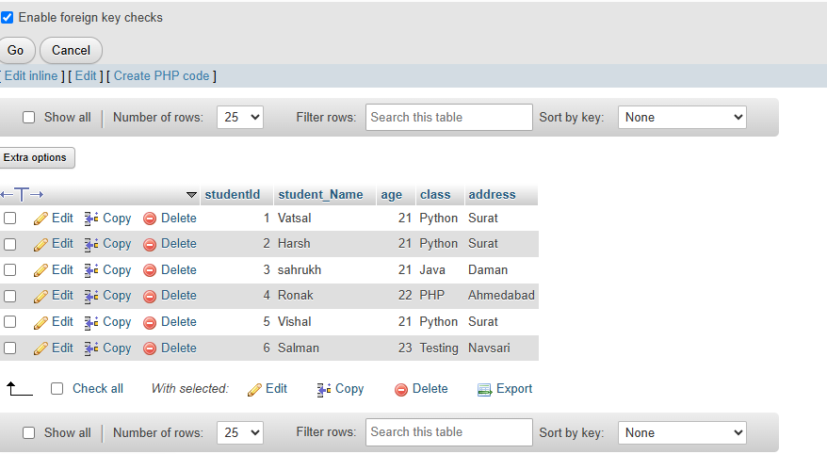

* SELECT student_Name,age FROM students

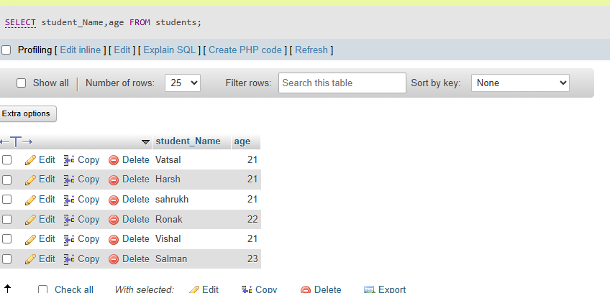

* SELECT * FROM students WHERE age>10

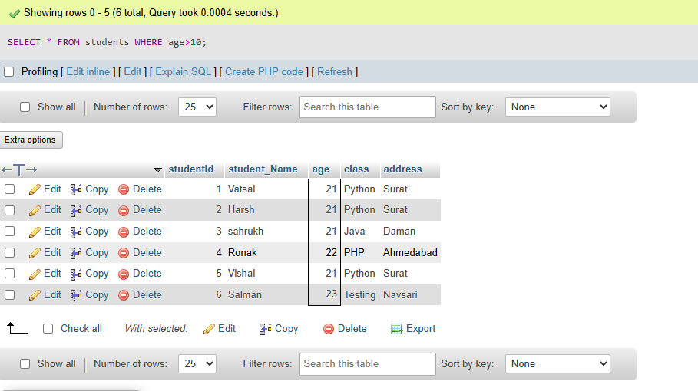

* CREATE TABLE teacher(teacher_id int PRIMARY key AUTO_INCREMENT,teacherName varchar(40)not null,subject varchar(40)not null , email varchar(20) UNIQUE);

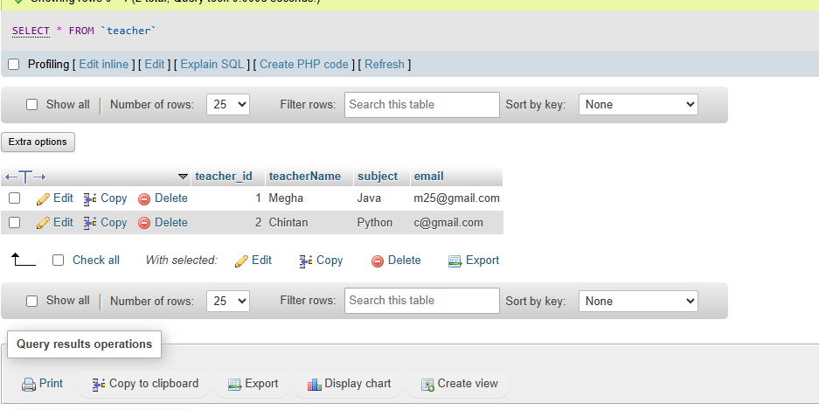

* alter table students add CONSTRAINT FOREIGN KEY (teacherId) REFERENCES teacher(teacher_id);
* CREATE TABLE courses(course_id int PRIMARY key,course_name varchar(20),course_credit int );
* alter table courses add COLUMN course_duration;
* ALTER TABLE courses DROP COLUMN course_credit
* drop table students
* drop table teacher
* INSERT INTO `courses`(`course_id`, `course_name`, `course_duration`) VALUES (101,"Python", "4 month");

INSERT INTO `courses`(`course_id`, `course_name`, `course_duration`) VALUES (102,"Java", "3 month");

INSERT INTO `courses`(`course_id`, `course_name`, `course_duration`) VALUES (103,"PHP", "2 month");

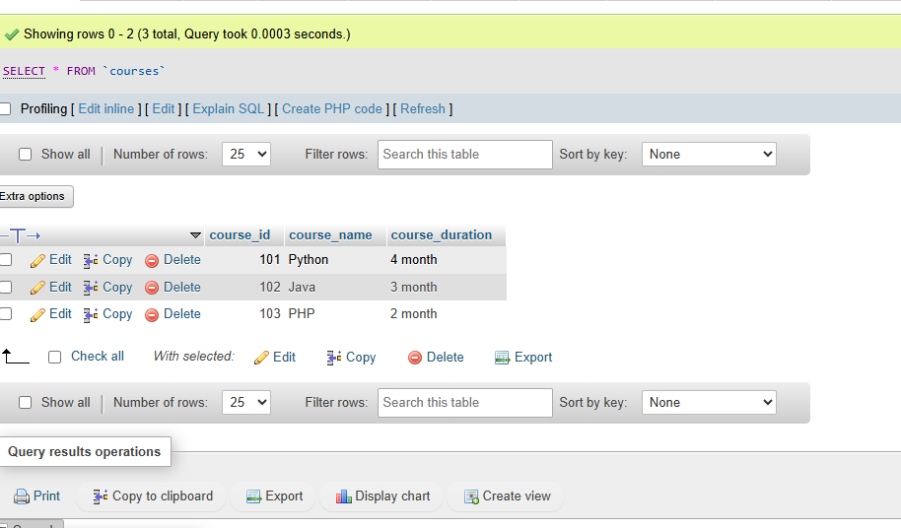

* UPDATE courses set `course_duration`="4 month" where `course_id`=102

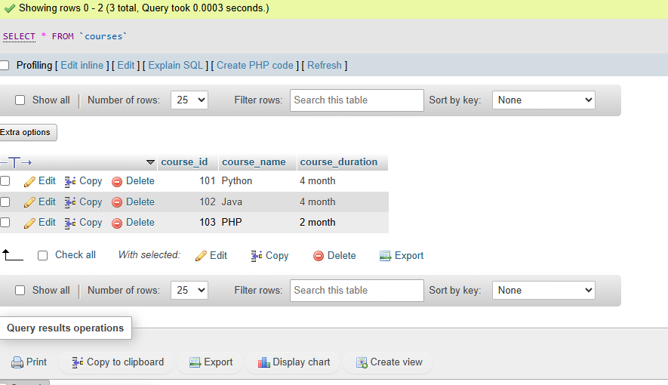

* DELETE FROM `courses` WHERE `course_id`=103

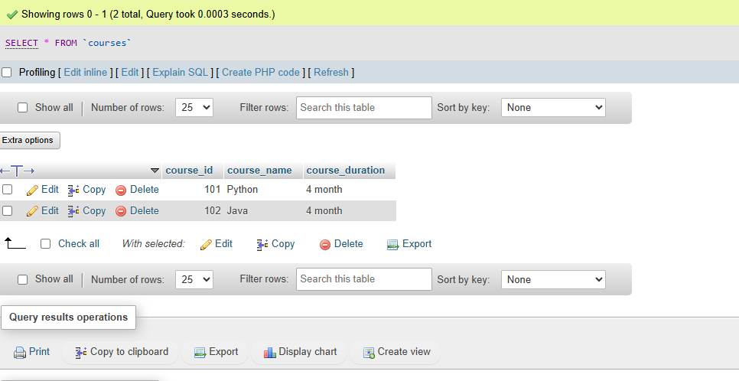

Lab 1: Retrieve all courses from the courses table using the SELECT statement.

Ans. SELECT * FROM courses;

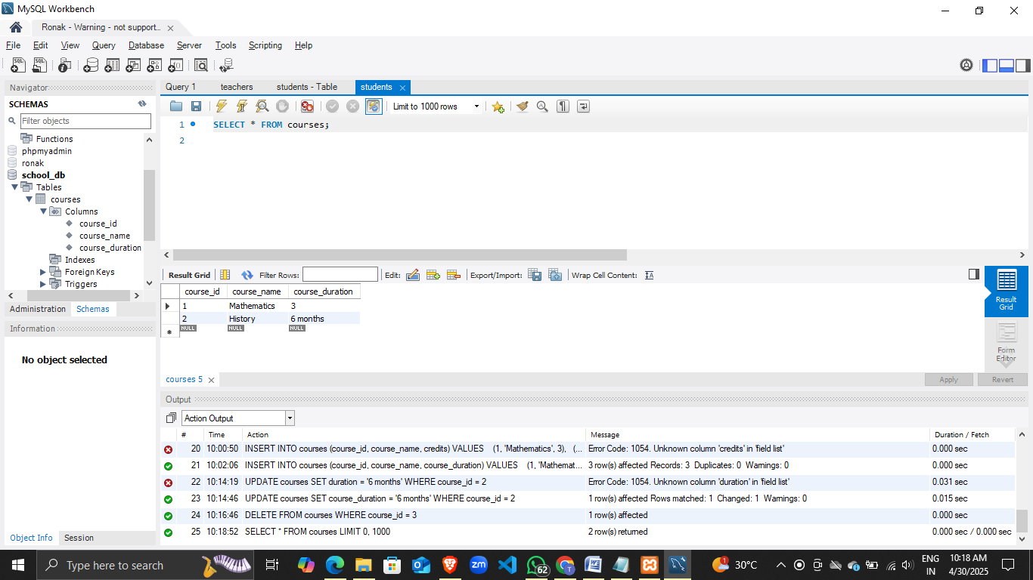

Lab 2: Sort the courses based on course_duration in descending order using ORDER BY.

Ans. SELECT * FROM courses

ORDER BY course_duration DESC;

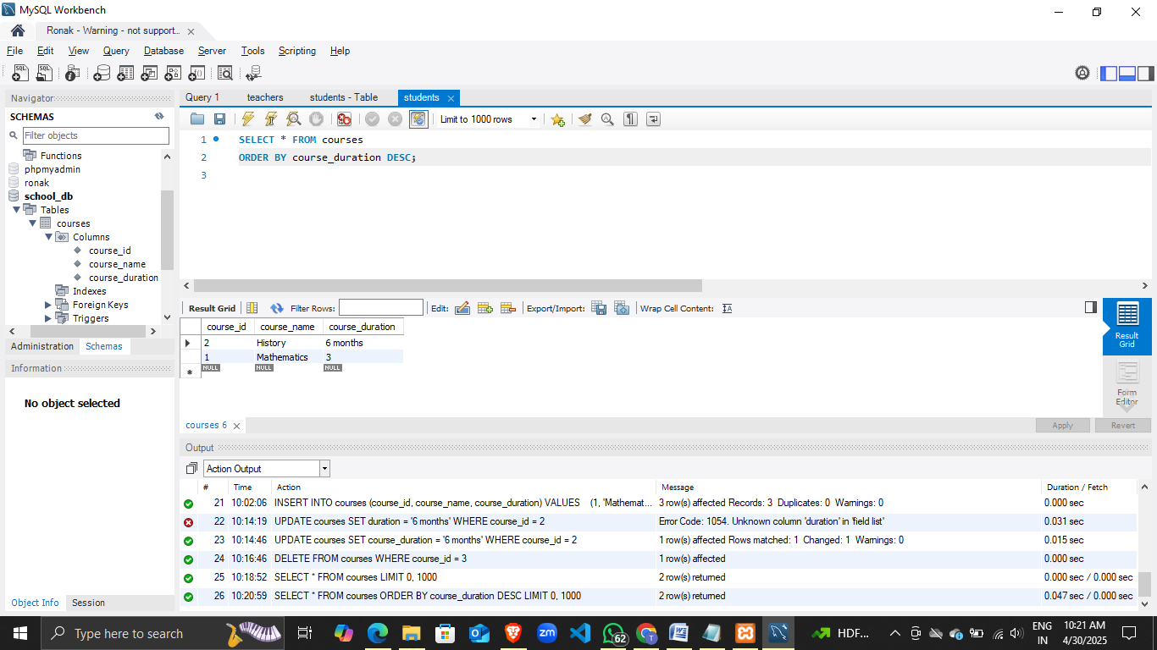

Lab 3: Limit the results of the SELECT query to show only the top two courses using LIMIT.

Ans. SELECT * FROM courses

LIMIT 2;

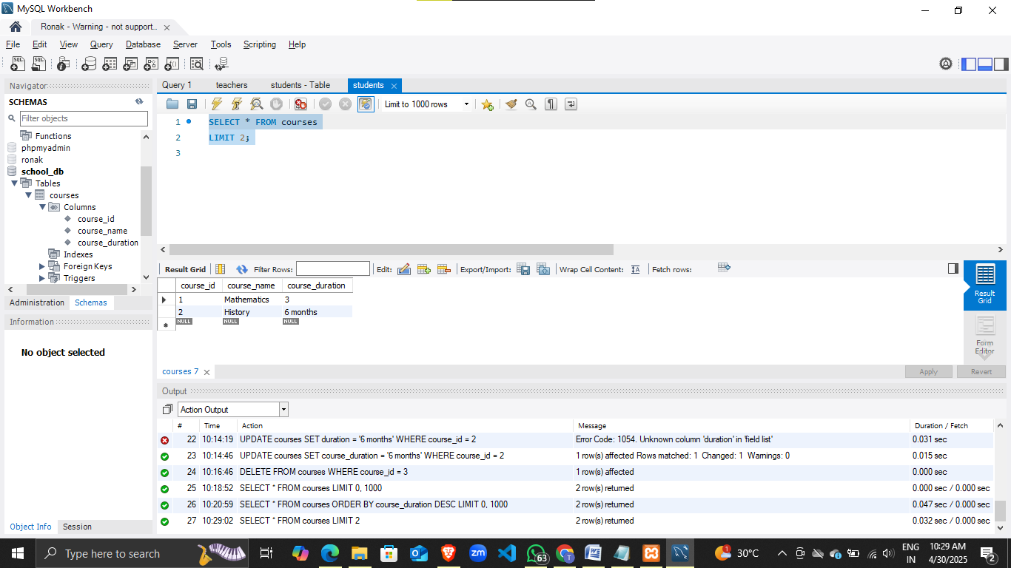

Lab 1: Create two new users user1 and user2 and grant user1 permission to SELECT from the courses table.

Ans. CREATE USER 'user1'@'localhost' IDENTIFIED BY 'password1';

CREATE USER 'user2'@'localhost' IDENTIFIED BY 'password2';

GRANT SELECT ON school_db.courses TO 'user1'@'localhost';

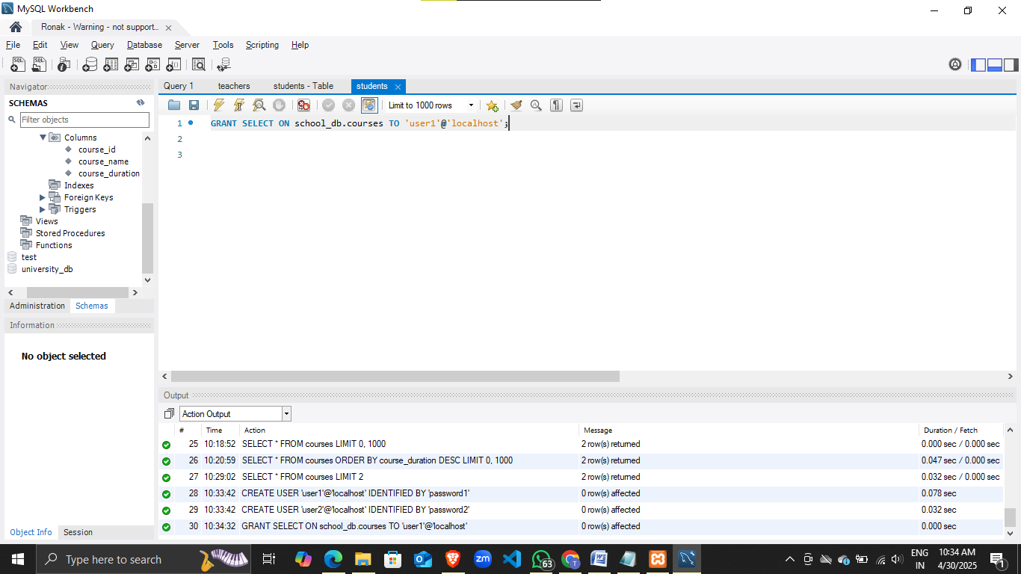

Lab 2: Revoke the INSERT permission from user1 and give it to user2.

Ans. REVOKE INSERT ON school_db.courses FROM 'user1'@'localhost';

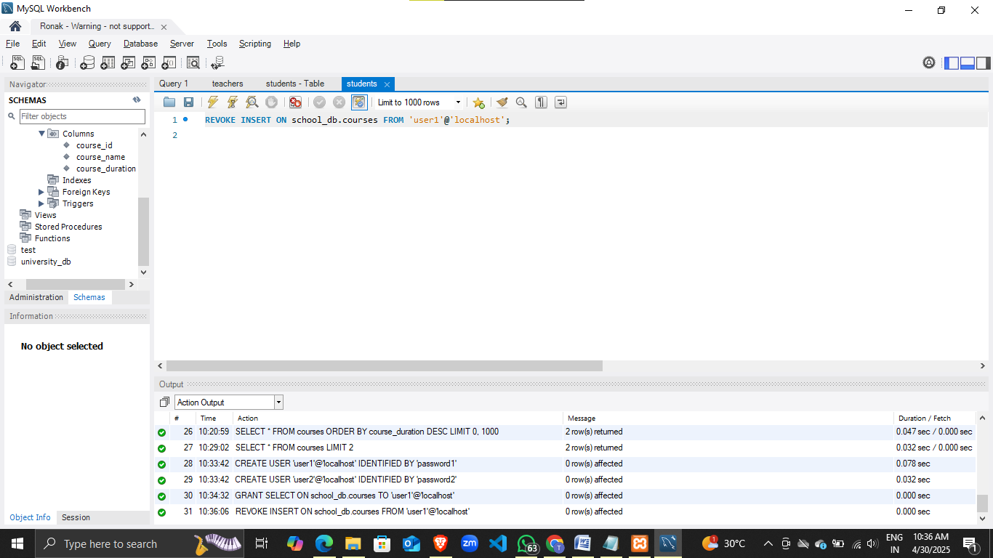

GRANT INSERT ON school_db.courses TO 'user2'@'localhost';

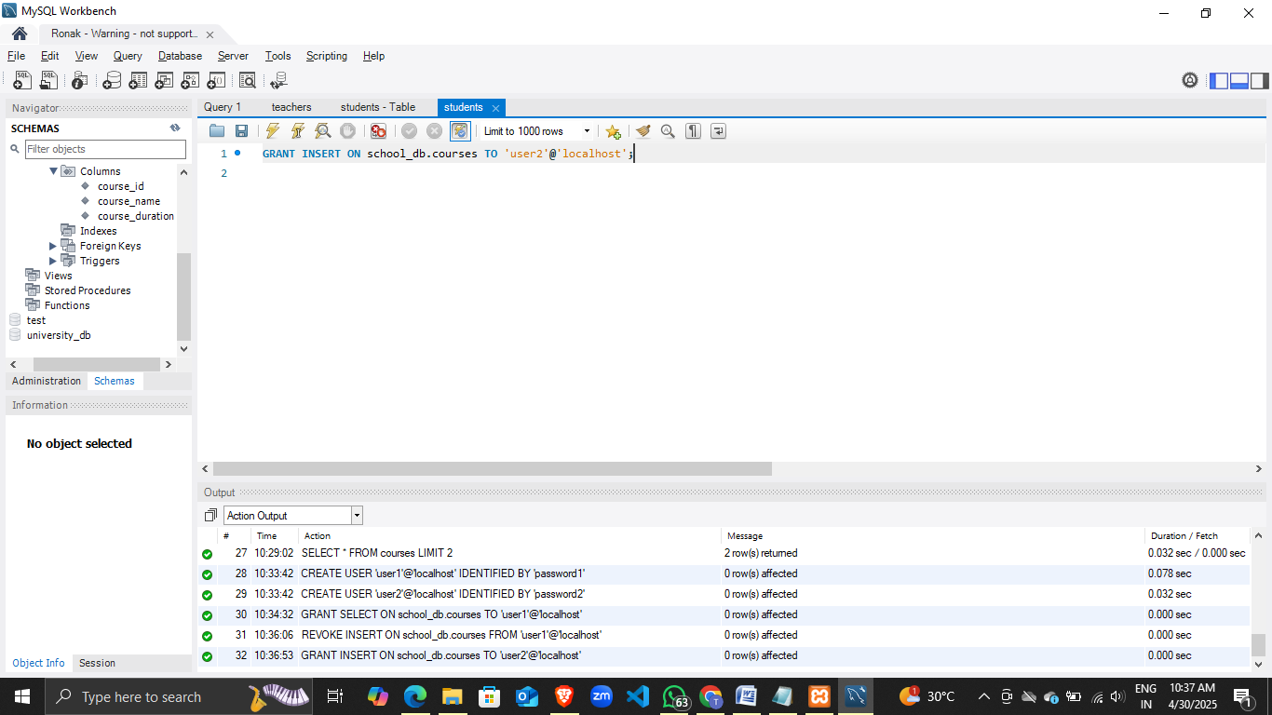

Lab 1: Insert a few rows into the courses table and use COMMIT to save the changes.

Ans. START TRANSACTION;

INSERT INTO courses (course_id, course_name, course_duration)

VALUES

(4, 'Physics', '6 months'),

(5, 'Chemistry', '5 months'),

(6, 'English', '4 months');

COMMIT;

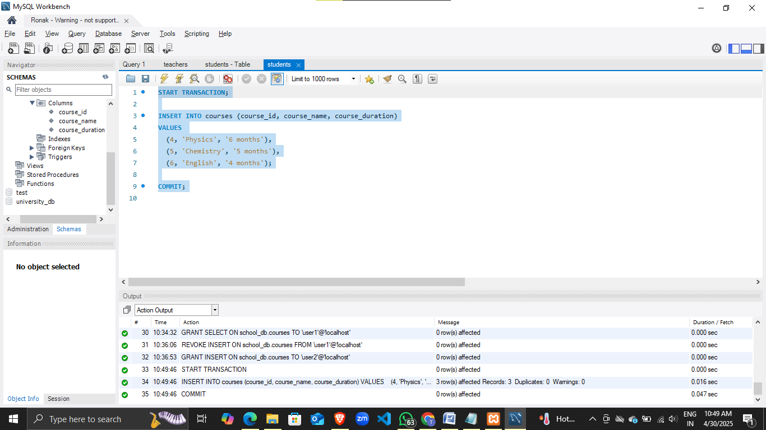

Lab 2: Insert additional rows, then use ROLLBACK to undo the last insert operation.

Ans. START TRANSACTION;

INSERT INTO courses (course_id, course_name, course_duration)

VALUES

(7, 'Computer Science', '8 months'),

(8, 'Economics', '6 months');

ROLLBACK;

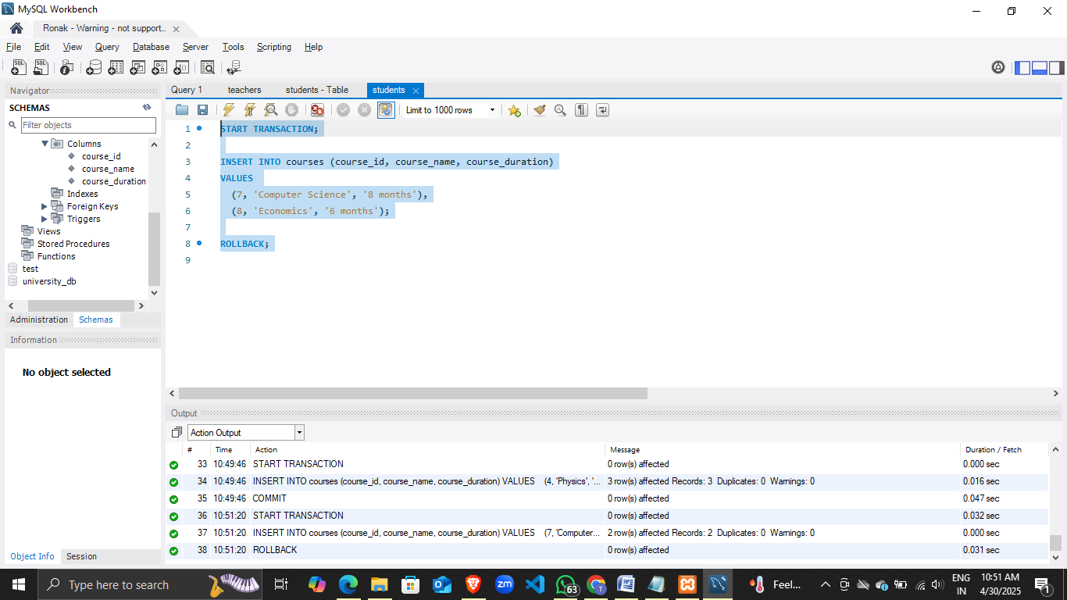

Lab 3: Create a SAVEPOINT before updating the courses table, and use it to roll back specific changes.

Ans. START TRANSACTION;

SAVEPOINT before_update;

UPDATE courses

SET course_duration = '10 months'

WHERE course_id = 4;

ROLLBACK TO SAVEPOINT before_update;

COMMIT;

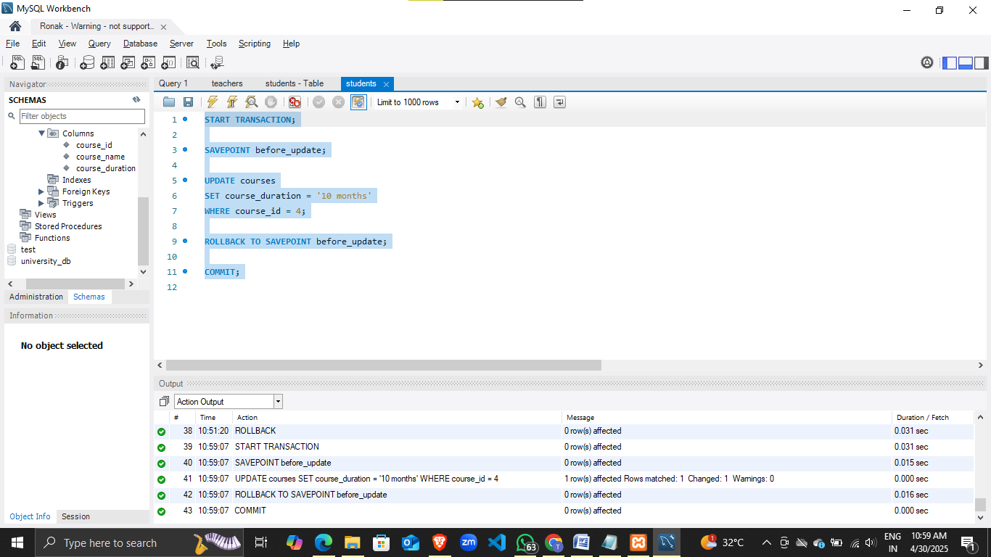

Lab 1: Create two tables: departments and employees. Perform an INNER JOIN to display employees along with their respective departments.

Ans. CREATE TABLE departments (

department_id INT PRIMARY KEY,

department_name VARCHAR(100)

);

CREATE TABLE departments (

dept_id INT PRIMARY KEY,

dept_name VARCHAR(50)

);

-- Create employees table

CREATE TABLE employees (

emp_id INT PRIMARY KEY,

emp_name VARCHAR(50),

dept_id INT,

FOREIGN KEY (dept_id) REFERENCES departments(dept_id)

);

-- Insert sample data

INSERT INTO departments (dept_id, dept_name) VALUES

(1, 'HR'),

(2, 'Finance'),

(3, 'IT'),

(4, 'Sales');

INSERT INTO employees (emp_id, emp_name, dept_id) VALUES

(101, 'Amit Kumar', 1),

(102, 'Priya Sharma', 2),

(103, 'Rahul Mehta', 3),

(104, 'Sneha Verma', 3);

-- INNER JOIN: show only employees who belong to departments

SELECT e.emp_id, e.emp_name, d.dept_name

FROM employees e

INNER JOIN departments d

ON e.dept_id = d.dept_id;

Lab 2: Use a LEFT JOIN to show all departments, even those without employees.

sql

Copy code

SELECT d.dept_id, d.dept_name, e.emp_id, e.emp_name

FROM departments d

LEFT JOIN employees e

ON d.dept_id = e.dept_id;

**Module 12: SQL Group By**

**Lab 1:** Group employees by department and count employees.

SELECT dept_id, COUNT(emp_id) AS total_employees

FROM employees

GROUP BY dept_id;

**Lab 2:** Find the average salary of employees in each department.

SELECT dept_id, AVG(salary) AS avg_salary

FROM employees

GROUP BY dept_id;

**Module 13: SQL Stored Procedure**

**Lab 1:** Retrieve all employees by department.

DELIMITER //

CREATE PROCEDURE GetEmployeesByDept(IN dept INT)

BEGIN

SELECT * FROM employees WHERE dept_id = dept;

END //

DELIMITER ;

**Lab 2:** Retrieve course details by course_id.

DELIMITER //

CREATE PROCEDURE GetCourseDetails(IN cid INT)

BEGIN

SELECT * FROM courses WHERE course_id = cid;

END //

DELIMITER ;

**Module 14: SQL View**

**Lab 1:** Show employees with department names.

CREATE VIEW emp_dept_view AS

SELECT e.emp_name, d.dept_name

FROM employees e

JOIN departments d

ON e.dept_id = d.dept_id;

**Lab 2:** Exclude employees earning below 50,000.

CREATE OR REPLACE VIEW emp_dept_view AS

SELECT e.emp_name, d.dept_name

FROM employees e

JOIN departments d

ON e.dept_id = d.dept_id

WHERE e.salary >= 50000;

**Module 15: SQL Triggers**

**Lab 1:** Log changes when a new employee is added.

CREATE TABLE employee_log (

log_id INT AUTO_INCREMENT PRIMARY KEY,

emp_id INT,

action VARCHAR(50),

log_time TIMESTAMP DEFAULT CURRENT_TIMESTAMP

);

CREATE TRIGGER after_employee_insert

AFTER INSERT ON employees

FOR EACH ROW

INSERT INTO employee_log(emp_id, action)

VALUES (NEW.emp_id, 'Inserted');

**Lab 2:** Update last_modified on employee update.

ALTER TABLE employees ADD last_modified TIMESTAMP;

CREATE TRIGGER before_employee_update

BEFORE UPDATE ON employees

FOR EACH ROW

SET NEW.last_modified = NOW();

**Module 16: Introduction to PL/SQL**

**Lab 1:** Count total employees.

DECLARE

total_employees INT;

BEGIN

SELECT COUNT(*) INTO total_employees FROM employees;

DBMS_OUTPUT.PUT_LINE('Total Employees: ' || total_employees);

END;

**Lab 2:** Calculate total sales from orders table.

DECLARE

total_sales NUMBER;

BEGIN

SELECT SUM(amount) INTO total_sales FROM orders;

DBMS_OUTPUT.PUT_LINE('Total Sales: ' || total_sales);

END;

**Module 17: PL/SQL Control Structures**

**Lab 1:** IF condition on employee department.

DECLARE

v_dept VARCHAR2(50);

BEGIN

SELECT dept_id INTO v_dept FROM employees WHERE emp_id = 101;

IF v_dept = 'IT' THEN

DBMS_OUTPUT.PUT_LINE('Employee is in IT Department');

ELSE

DBMS_OUTPUT.PUT_LINE('Employee is not in IT Department');

END IF;

END;

**Lab 2:** FOR LOOP to display employee names.

BEGIN

FOR rec IN (SELECT emp_name FROM employees) LOOP

DBMS_OUTPUT.PUT_LINE('Employee: ' || rec.emp_name);

END LOOP;

END;

**Module 18: SQL Cursors**

**Lab 1:** Explicit cursor for employees.

DECLARE

CURSOR emp_cursor IS SELECT emp_id, emp_name FROM employees;

v_id employees.emp_id%TYPE;

v_name employees.emp_name%TYPE;

BEGIN

OPEN emp_cursor;

LOOP

FETCH emp_cursor INTO v_id, v_name;

EXIT WHEN emp_cursor%NOTFOUND;

DBMS_OUTPUT.PUT_LINE('ID: ' || v_id || ' Name: ' || v_name);

END LOOP;

CLOSE emp_cursor;

END;

**Lab 2:** Cursor for courses.

DECLARE

CURSOR c_cursor IS SELECT course_name FROM courses;

v_course VARCHAR2(50);

BEGIN

OPEN c_cursor;

LOOP

FETCH c_cursor INTO v_course;

EXIT WHEN c_cursor%NOTFOUND;

DBMS_OUTPUT.PUT_LINE('Course: ' || v_course);

END LOOP;

CLOSE c_cursor;

END;

**Module 19: Rollback and Commit Savepoint**

**Lab 1:** Rollback to savepoint.

START TRANSACTION;

INSERT INTO courses VALUES (106, 'Biology', 3, 4);

SAVEPOINT save1;

INSERT INTO courses VALUES (107, 'Chemistry', 3, 5);

ROLLBACK TO save1;

**Lab 2:** Commit part, rollback rest.

START TRANSACTION;

INSERT INTO courses VALUES (108, 'Economics', 3, 4);

SAVEPOINT save2;

INSERT INTO courses VALUES (109, 'Geography', 2, 3);

COMMIT;

ROLLBACK TO save2;

**📌 Extra Lab Practice (Library DB)**

**Extra SQL – Introduction to SQL**

**Lab 3:** Create library_db with books.

CREATE DATABASE library_db;

USE library_db;

CREATE TABLE books (

book_id INT PRIMARY KEY,

title VARCHAR(100),

author VARCHAR(50),

publisher VARCHAR(50),

year_of_publication INT,

price DECIMAL(8,2)

);

INSERT INTO books VALUES

(1, 'DBMS Concepts', 'Korth', 'McGrawHill', 2015, 550),

(2, 'SQL Fundamentals', 'James', 'Pearson', 2018, 650),

(3, 'Oracle PL/SQL', 'Scott', 'Wiley', 2012, 700),

(4, 'Database Systems', 'Navathe', 'Pearson', 2020, 800),

(5, 'SQL Queries', 'Martin', 'O’Reilly', 2019, 600);

**Lab 4:** Create members table.

CREATE TABLE members (

member_id INT PRIMARY KEY,

member_name VARCHAR(50),

date_of_membership DATE,

email VARCHAR(100)

);

INSERT INTO members VALUES

(1, 'Anita', '2020-01-15', 'anita@gmail.com'),

(2, 'Ravi', '2019-07-12', 'ravi@yahoo.com'),

(3, 'Meera', '2021-03-20', 'meera@hotmail.com'),

(4, 'Ajay', '2018-11-05', 'ajay@gmail.com'),

(5, 'Kiran', '2022-06-10', 'kiran@gmail.com');